Revenue Scotland
Green Strategy

Contents
1
1. Purpose 3
2. Public Sector climate change duties 3
3. Background 4
4. Governance and management of climate change in Revenue Scotland 4
5. Revenue Scotland’s Environmental Objectives 6

1. Purpose

This Strategy aims to strengthen and drive forward Revenue Scotland’s environmental performance and ensure that we:

- reduce our impact on environment
- minimise our carbon emissions
- meet our climate change duties
- embed climate change action into its organisational culture

To achieve this, the Strategy :

- sets out arrangements for governance and management of Revenue Scotland’s environmental performance to ensure robust implementation of climate change action

- Sets out Revenue Scotland’s environmental objectives

- Sets out a high level action plan and key activities to be carried out by Revenue Scotland in order to achieve each of those objectives

2. Public Sector climate change duties

Under Part 4 of the Climate Change (Scotland) Act 2009, Revenue Scotland has a statutory duty to act:
a) in the way best calculated to contribute to the delivery of of (Scotland’s climate change) targets
(b) in the way best calculated to help deliver any any (Scottish adaptation programme) laid before the Scottish Parliament under section 53;
(c) in a way that it considers is most sustainable

3. Background

Revenue Scotland is the Scottish tax authority responsible for the collection and management of the devolved taxes in Scotland. Revenue Scotland was established on 1 January 2015 as a Non-ministerial department of the Scottish Administration.

Revenue Scotland is a relatively small organisation employing around 41 staff. We occupy a minor office space within the Scottish Government’s Victoria Quay building in Edinburgh. Our heating, lighting and water services are managed through a service level agreement and carbon emissions are monitored and reported by Scottish Government on building wide basis.

We therefore lack detailed data to set out specific emissions targets in relation to our office energy consumption. Nevertheless, we are fully committed to act sustainably in respect of our workplace practices.

4. Governance and management of climate change in Revenue Scotland

We recognise that a robust climate change governance and management structure which engages staff at all levels is essential for ensuring that climate change action is being implemented efficiently and is embedded in our organisational culture.

4.1 Our climate change governance and management structure

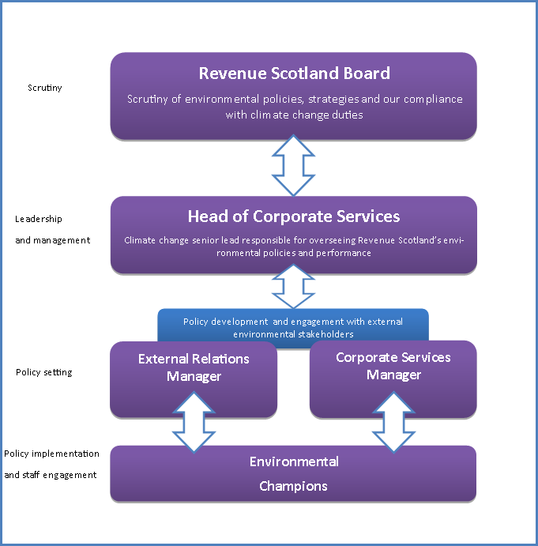

5. Revenue Scotland’s Environmental Objectives

Objective 1

To manage and monitor business travel and encourage staff to use the most carbon efficient method of transport for all work-related travel

To meet this objective, we will ensure that:

- our Business Travel Strategy is easily accessible and visible to all staff
- staff are encouraged to use public transport or car share for work–related travel
- where possible and appropriate, video conferencing facilities are used as an alternative or addition to face-to-face meetings
- whenever possible, webinars are used as a platform for stakeholder engagements
- flexible working options are available to staff affected by temporary travel disruptions in particular where public transport is unavailable
- a sustainable travel policy is applied transparently and equally across the entire workforce
- we will set emission targets for our business travel and monitor progress

Objective 2

To minimise waste and reduce Revenue Scotland’s paper use

To meet this objective, we will ensure that:

- staff are encouraged to reduce the use of print outs for internal meetings and use our A/V facilities instead
- white printing paper is replaced with recycled printing paper when staff require prints for their own use
- our clear desk policy is complied with and enforced
- recycling bins are available in our office and staff are encouraged to recycle paper
- we follow the Scottish Government’s ‘Digital by default’ approach and encourage electronic submissions of tax returns and payments
- we use our website and social media effectively and continue to grow our mailing lists to make our communications more widely available and easily accessible
- webinars are used as an alternative to events for stakeholder engagements
- we develop targets for reducing paper usage and set out an action plan to meet them

Objective 3

To reduce our office energy consumption

We are committed to contribute to the overall reduction in carbon footprint for our premises and we will ensure that we:

- work in partnership with SEPA, the Sustainable Scotland Network and the Scottish Government environmental policy unit to develop our climate change expertise
- highlight our environmental policies in the induction package for new staff and on Revenue Scotland’s wiki
- clearly set out the roles and responsibilities of Revenue Scotland’s environmental champions and ensure that at all times we have at least one staff member trained to perform this role
- ensure that recycling bins are available in our offices and encourage staff to manage and recycle waste efficiently
- ensure that lights and A/V equipment in our meeting room are switched off when not being used
- encourage staff to switch off their PCs when they are going to be away from their work stations for longer periods of time
- ensure that windows are not left open overnight or on days when the office is closed to minimise heat loss

